Content Delivery Network – CDN

## **What is Content Delivery Network (CDN)**

A content delivery network or content distribution network (CDN) is a globally distributed network of proxy servers deployed in multiple data centers. The goal of a CDN is to serve content to end-users with high availability and high performance. CDNs serve a large fraction of the Internet content today, including web objects (text, graphics and scripts), downloadable objects (media files, software, and documents), applications (e-commerce, portals), [live streaming](https://en.wikipedia.org/wiki/Live_streaming) media, on-demand streaming media, and [social networks](https://en.wikipedia.org/wiki/Social_network).

## **What are benefits of CDN Service?**

This service is effective in speeding the delivery of content of websites with high traffic and websites that have global reach. The closer the CDN server is to the user geographically, the faster the content will be delivered to the user. CDNs also provide protection from large surges in [traffic](http://www.webopedia.com/TERM/T/traffic.html). Servers nearest to the website visitor respond to the request. The CDN copies the pages of a website to a network of servers that are dispersed at geographically different locations, caching the contents of the page.

The benefits of using the CDN to cache web site assets are as follows

* Better performance and user experience for end users, especially when using applications where multiple round-trips are required to load content.
* Large scaling to better handle instantaneous high load, like at the start of a product launch event.
* By distributing user requests and serving content from edge servers, less traffic is sent to the origin.

## **How CDN Service works?**

To minimize the distance between the visitors and website’s server, CDN service stores a cached version of its content in multiple geographical locations (i.e. points of presence- PoP). Each PoP contains a number of caching servers responsible for content delivery to visitors within its region.

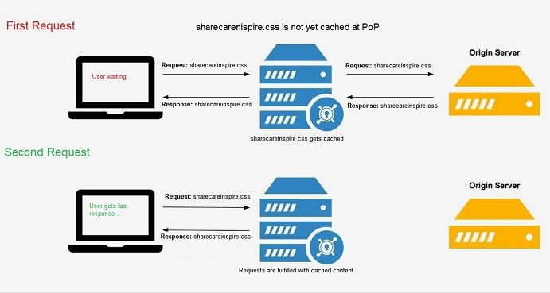How CDN works

## **Who provides CDN Service?**

Privately owned companies provide CDN service. Also generally speaking, all Internet service providers can provide a content delivery network.

There are few companies who provide free services too, following are few of them.

Free CDNs

* [BelugaCDN](https://en.wikipedia.org/w/index.php?title=BelugaCDN&action=edit&redlink=1)
* [BootstrapCDN](https://en.wikipedia.org/wiki/BootstrapCDN)
* [Cloudflare](https://en.wikipedia.org/wiki/Cloudflare)

Commercial CDNs  
Many companies provide commercial CDN services, following are few examples.

* [Akamai Technologies](https://en.wikipedia.org/wiki/Akamai_Technologies)
* [Amazon CloudFront](https://en.wikipedia.org/wiki/Amazon_CloudFront)
* [Aryaka](https://en.wikipedia.org/wiki/Aryaka)
* [Azure CDN](https://en.wikipedia.org/wiki/Azure_Services_Platform)
* [CacheFly](https://en.wikipedia.org/wiki/CacheFly)
* net
* CDNetworks
* CDNsun
* [ChinaCache](https://en.wikipedia.org/wiki/ChinaCache)
* [Cloudflare](https://en.wikipedia.org/wiki/Cloudflare)
* [HP Cloud Services](https://en.wikipedia.org/wiki/HP_Cloud_Services)

Telco CDNs  
Telephone service providers are provide CDNs services, following are few of them

* [AT&T Inc.](https://en.wikipedia.org/wiki/AT%26T_Inc.)
* [Bharti Airtel](https://en.wikipedia.org/wiki/Bharti_Airtel)
* [Bell Canada](https://en.wikipedia.org/wiki/Bell_Canada)
* [BT Group](https://en.wikipedia.org/wiki/BT_Group)
* [China Telecom](https://en.wikipedia.org/wiki/China_Telecom)
* [Deutsche Telekom](https://en.wikipedia.org/wiki/Deutsche_Telekom)

## **What is Multi CDN?**

Different CDNs tend to vary in performance in different areas, and some may offer a better service in video optimization.

Multi-CDN is the practice of using more than one CDN provider in order to further improve latency and uptimes on a global scale. While one CDN may be enough in a certain locality, a site owner may choose to implement further CDNs that have data centers in geographical areas where the main supplier isn’t highly represented.

Multi CDN providers

* [CDN-Tech](https://en.wikipedia.org/w/index.php?title=CDN-Tech&action=edit&redlink=1)
* [Cloakfusion](https://en.wikipedia.org/w/index.php?title=Cloakfusion&action=edit&redlink=1)
* [GlobalDots](https://en.wikipedia.org/w/index.php?title=GlobalDots&action=edit&redlink=1)
* [MetaCDN](https://en.wikipedia.org/wiki/MetaCDN)

# With Microsoft Azure Web App

## **Introduction**

Azure operates out of facilities located in number of regions around the world, and that number is increasing every year. In addition, Azure also strategically places CDN point of presence (POP) locations to deliver content to end users. You can cache content from Azure Storage, Web Apps, and Azure Cloud Services.

When a user requests content by the CDN URL, the content is directly served from the CDN node, if the content exists. Otherwise, the content will be retrieved from the content origin and stored at the CDN node for future requests.

To know more about how CDN works and who CDN providers are, please refer article [Content Delivery Network](http://www.sharecareinspire.com/content-delivery-network-cdn-part-1/)

## **Azure CDN**

The Azure Content Delivery Network (CDN) caches static web content at strategically placed locations to provide maximum throughput for delivering content to users. The CDN offers developers a global solution for delivering high-bandwidth content by caching the content at physical nodes across the world.

The benefits of using the CDN to cache web site assets include:

* Better performance and user experience for end users, especially when using applications where multiple round-trips are required to load content.
* Large scaling to better handle instantaneous high load, like at the start of a product launch event.
* By distributing user requests and serving content from edge servers, less traffic is sent to the origin.

Azure provider option to configure CDN among these CDN providers: Standard from Akamai, Standard from Verizon, and Premium from Verizon.

Out of these provides Premium from Verizon provides most of the features as follows

* Token authentication
* Separate rules for mobile devices
* URL redirect.

Following are few important features provided by all three providers.

* Easy integration with Azure services
* Management via[REST API](https://msdn.microsoft.com/library/mt634456.aspx), [.NET](https://docs.microsoft.com/en-us/azure/cdn/cdn-app-dev-net), [js](https://docs.microsoft.com/en-us/azure/cdn/cdn-app-dev-node), or [PowerShell](https://docs.microsoft.com/en-us/azure/cdn/cdn-manage-powershell).
* Load balancing
* [DDOS](https://www.us-cert.gov/ncas/tips/ST04-015)protection
* HTTPS support
* Custom domain

Azure CDN can be configured with Azure Web App, Azure Cloud Service, Azure Storage account, Media services or any publicly accessible web server.

This article focuses on configuring CDN with Azure Web apps.

## **When does content gets expired on CDN edge Server?**

The origin (Web App Server) returns the file to the edge server, including optional HTTP headers describing the file’s Time-to-Live (TTL).

The edge server caches the file and returns the file to the original requestor. The file remains cached on the edge server until the TTL expires. If the origin didn’t specify a TTL, the default TTL is seven days.

Additional users may then request the same file using that same URL, and may also be directed to that same POP.

If the TTL for the file hasn’t expired, the edge server returns the file from the cache. This results in a faster, more responsive user experience.

## **Steps to Configure CDN Profile and CDN endpoint**

### **Step 1: Create Azure Web App**

Though Azure CDN can be configured with Azure Web App, Azure Cloud Service, Azure Storage account, or any publicly accessible web server, I am focusing on Azure Web app here. Hence let’s create web app first.

Navigate to New -> Web + Mobile -> Web App to create new web app. Provide required details and click on create button, which will initiate provisioning of new web app.

### **Step 2: Configure CDN Profile**

A CDN profile is a collection of CDN endpoints. Each profile contains one or more CDN endpoints. You may wish to use multiple profiles to organize your CDN endpoints by internet domain, web application, or some other criteria. By default, a single Azure subscription is limited to eight CDN profiles.

Once application is created, in order to configure CDN, navigate to properties of web app. Under settings section you will find Networking option, select the same and it will open new blade which will enable you to configure CDN.

Web App -> Settings -> Networking

This blade enables you to setup VNET integration and Hybrid connections along with CDN configuration.

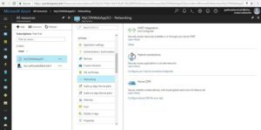Configure CDN

Click on the “configure Azure CDN for you app” link, it will open new blade to create a CDN Profile and an endpoint.

Provide CDN profile details like, profile name, CDN provider, CDN endpoint name and click on create button to create CDN profile and an endpoint.

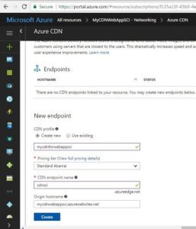Configure CDN Profile

It will take some time create the CDN profile and CDN endpoint, once it finished provisioning, you can see it in all resources section.

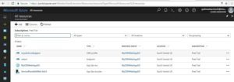List of CDN Profiles

### **Step 3: Test CDN endpoint**

Now web app is configured to use CDN, and it’s time to test if CDN is working fine. If you select the CND endpoint and check its overview in settings blade, it shows CDN endpoint URL and original hostname.

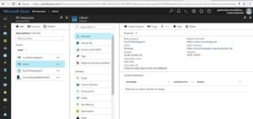CDN endpoint

By the time I have made the changes to original web app and included another web page as a default page.

If you want to know how to setup default page for web app, please refer article [how to make changes to pages](http://www.sharecareinspire.com/how-to-make-changes-to-pages-and-files-on-web-apps-form-arm-portal/).

http://mycdnwebappsci.azurewebsites.net

Web App Default Page

I then navigated to the CDN endpoint to see if it also shows me same results, but it’s was not. it proves that it takes some time to cache the content on CDN cache servers.

https://cdnsci.azureedge.net

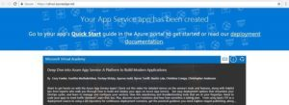CDN Default Page

### **Step 4: Purge CDN Content**

If you want to forcefully remove the content of CDN cache server and push new content to CDN servers, Azure has provided an option called purge. If select CDN endpoint and check its settings in overview tab, you will find purge button on the top.

Azure do not support the purge wildcard content, hence you have to be very specific to purge the content, which makes sense, as purging entire content means revamping entire site.

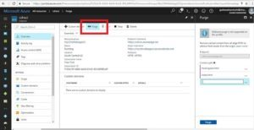CDN Purge

### **Step 5: Testing CDN Endpoint after purging**

After purging as expected, page did not reflect immediately on CDN endpoint, took some time (may be around an 10 mins in my case), and finally my modified page is shown.

CDN Modified Page

in subsequent parts of CDN,  Will try to cover how to check the performance and, configure CDN for optimization.

Every website is different and unique in terms of its services and its user base, some web sites provide service as a video gallery, some as images gallery and some as content management.  Based on the type of content of site and needs of the users, CDN configuration too needs to be different for each type of web site to achieve optimized performance.

Azure provides multiple configuration options to optimize CDN for better performance.

To know about how CDN works and who CDN providers are, please refer article [Content Delivery Network](http://www.sharecareinspire.com/content-delivery-network-cdn-part-1/)– Part1

If you are further interested in configuring CDN with Azure Web app please [Content Delivery Network](http://www.sharecareinspire.com/content-delivery-network-cdn-part-2-with-microsoft-azure-web-app/)– Part2.

# Advanced Configuration of CDN endpoint for optimization

1. Content CachingYou have option to cache content based on the query string, you can either opt to cache each and every request based on different query string, or can opt to ignore the query string.  
Ignore query strings: This is the default mode. With this configuration page will be cached on CDN edge note at first request, on subsequent requests query string will be straightaway ignored. Hence does not make sense to pass different query string values here, same content will be returned.  
Bypass caching for URL with query strings: In this mode, requests with query strings are not cached at the CDN edge node. The edge node retrieves the asset directly from the origin and passes it to the requestor with each request.  
Cache every unique URL: This mode treats each request with a query string as a unique asset with its own cache.

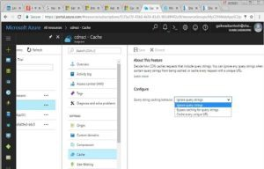Cache

2. Optimization:  
Depending on the optimization CDN providers support and how they apply enhancement in different scenarios, “optimized for” options can vary based on the provider you select. Currently Azure CDN from Akamai supports general web delivery, general media streaming, video on demand media streaming, and large file download. Azure CDN from Verizon supports general web delivery. You can use general web delivery for video on demand and large file download.

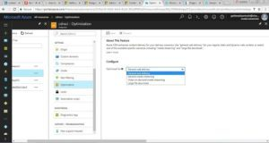Optimization

3. Compression  
Compression is a simple and effective method to improve file transfer speed and increase page load performance by reducing file size before it is sent from the server. It reduces bandwidth costs and provides a more responsive experience for your users.

There are two ways to enable compression:

* You can enable compression on your origin server, in which case the CDN will pass through the compressed files and deliver compressed files to clients that request them.
* You can enable compression directly on CDN edge servers, in which case the CDN will compress the files and serve it to end users, even if they are not compressed by the origin server.

You can specify which type of files need to be compressed.

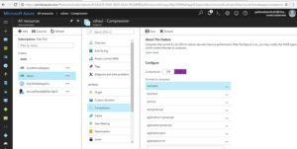Compression

4. Custom Domain  
You can map a custom domain to a CDN endpoint in order to use your own domain name in URLs to cached content rather than using a subdomain of azureedge.net.

e.g. you can have your own cnd domain like cdn.sharecareinspire.com and map to cdnsci. azureedge.net

* Create a CNAME record with your domain registrar and map your custom domain and subdomain to the CDN endpoint. The process of mapping your custom domain to your CDN endpoint can, however, result in a brief period of downtime for the domain while you are registering the domain in the Azure Portal.
* Add an intermediate registration step withcdnverify.  If your custom domain is currently supporting an application with a service-level agreement (SLA) that requires that there be no downtime, then you can use the Azure cdnverify subdomain to provide an intermediate registration step so that users will be able to access your domain while the DNS mapping takes place.

I am not covering here any of these two options as it needs a registered domain name, which I don’t have at the moment.

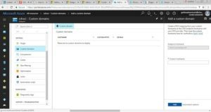Custom Domain